# Tree View for the reports

To structure the information in reports better. A python program is designed to parse the reports and converted them into a HTML file with Tree view structure (Fig 4). The contents in a same section from every reports are captured and put in the same category. In future development, search and filter function may be added into this so that user can capture the useful information more conveniently.

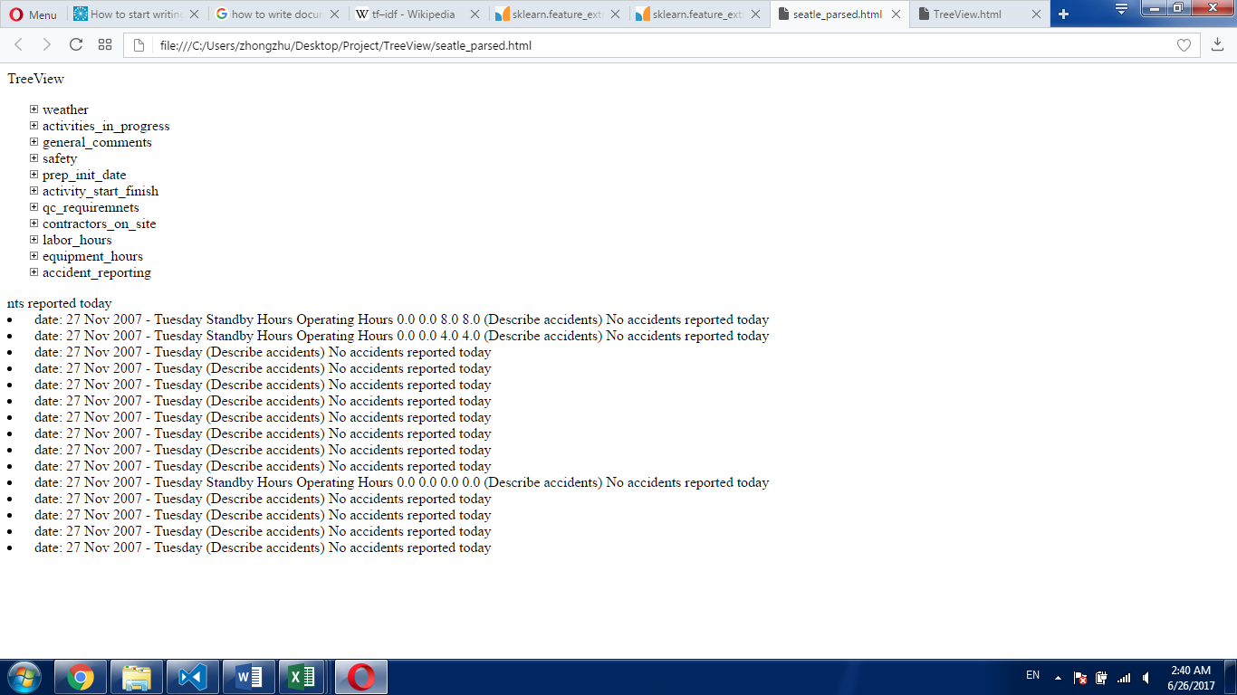

Fig 4: Tree View of the reports

Another python program is designed to capture the key words in the reports. The program searches the provided key words’ stem form( a word’s stem form means its basic part. i.e. the stem form of word “footings” is “foot”). If a line in the report contains the all words which share the same stem form with the given key words combination, then the program put this line into corresponding category. For example, the program find a line **“backfill foundation in west loop B ( 59 to 63 ) Prep for sidewalk / driveway east loop”** contains the words “**backfil**l” and “**foundation**”, which satisfy the key words combination **"Backfilling + Foundations**", so this line is put under the category **“01113 Excavating & Backfilling”.** Part of the result is shown below (Fig 5).

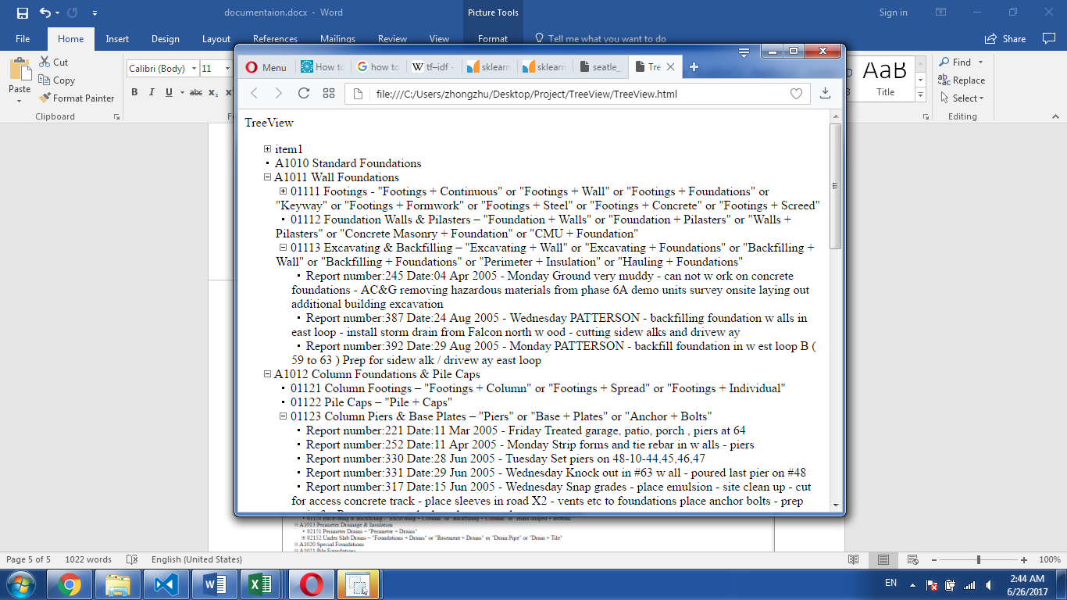

Fig 5: Results of Searching Key Words